**Assignment 3 – NLP (POS Tagger) – VCU** SPRING2018

**Name**: Ikram Hamizi

**Professor**: Bridget McInnes

**Screenshots:** POS Tagger.pl and Scorer.pl

* Before Adding rules

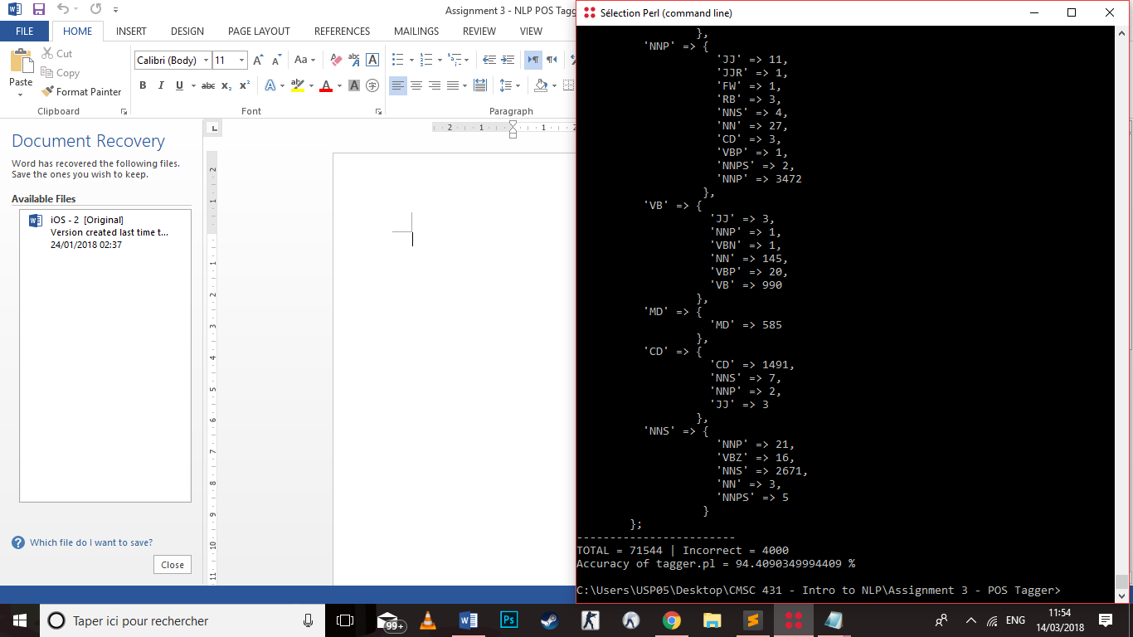

* After adding rules (increase of 0.46%)

